Record Description Form |  | Durham Bird Club | 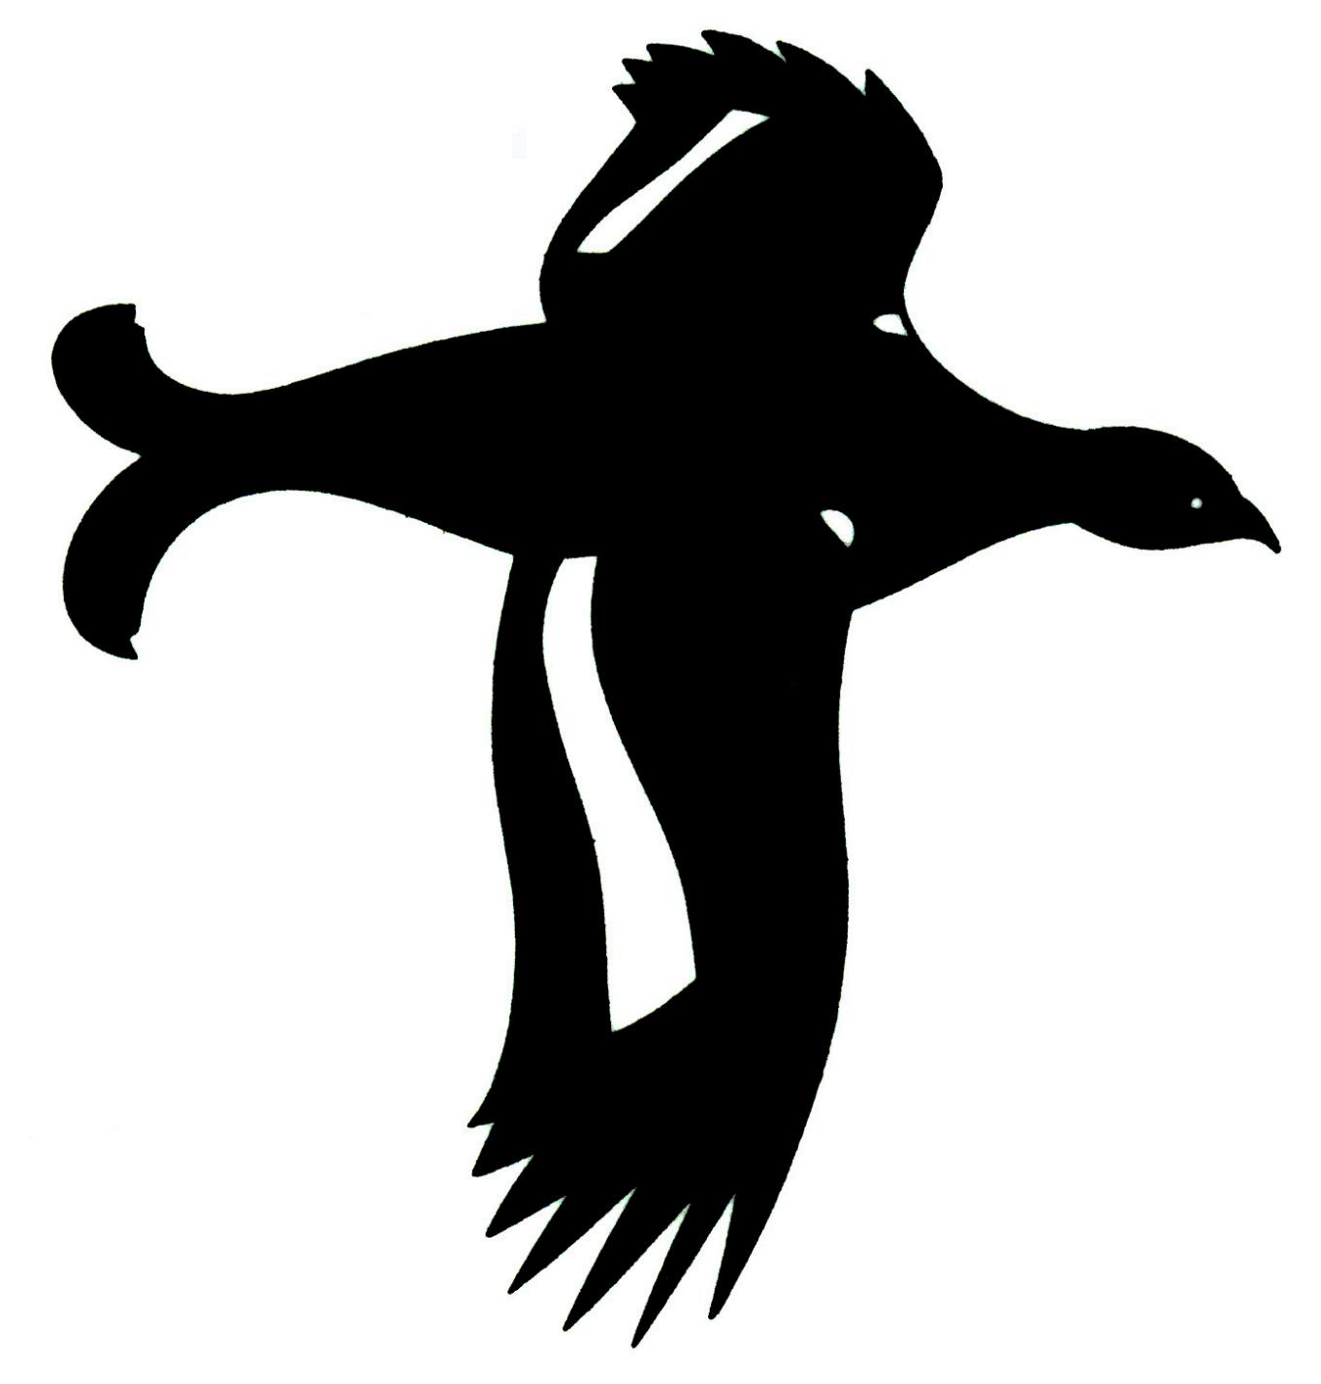
Species:
Number of birds:
Age:
Date:
Locality:
Observer’s name and address:
Observer’s telephone no:
Other observers:
Who found the bird:
Who first identified it:
Optical aids used:
Was it photographed and if so by whom:
Species present/ alongside for comparison:
Distance from bird:
Weather conditions:
Wind/ light conditions, visibility etc.
Experience of this and similar species:
Description:
Remember to include the circumstances of how you found the bird and details of it's behaviour and 'jizz'. Ensure you describe all the plumage characters you saw which are relevant to the identification, and include details of the bare parts and any song/calls heard.

